ST. XAVIER’S COLLEGE

**(Affiliated to Tribhuvan University)**

Maitighar, Kathmandu



**Computer Graphics Lab Assignment #8**

**Submitted by:**

Pratibha Panta

013BSCCSIT028

**Submitted to:**

|  |  |
| --- | --- |
| Er. Anil Sah  Lecturer, St. Xavier’s College |  |

**Statement: To perform reflection through x-axis and y-axis.**

**Algorithm**

1. Get the width and height of the source image

2. Get parameter for reflection axis (1 for x-axis, 2 for y-axis)

3. For each point i in width

For each point j in height

If parameter==1

The translated point (x’, y’) is given by

x' = i

y’ = - j

If parameter==2

The translated point (x’, y’) is given by

x' = - i

y’ = j

Plot the points (x’, y’) with the same color as source in destination

4. Stop

**Source Code**

#include <vcl\vcl.h>

#pragma hdrstop

#include "Unit1.h"

//---------------------------------------------------------------------------

#pragma resource "*.dfm"

TForm1 *Form1;

int i,j,x,y,a,b;

//---------------------------------------------------------------------------

__fastcall TForm1::TForm1(TComponent* Owner)

: TForm(Owner)

{

}

//---------------------------------------------------------------------------

void __fastcall TForm1::XClick(TObject *Sender)

{

x=Image1->Height;

y=Image1->Width;

for(i=0;i<x;i++)

{

for(j=0;j<y;j++)

{

a=x-i;

b=j;

Image2->Canvas->Pixels[a][b]=Image1->Canvas->Pixels[i][j];

}

}

}

//---------------------------------------------------------------------------

void __fastcall TForm1::YClick(TObject *Sender)

{

x=Image1->Height;

y=Image1->Width;

for(i=0;i<x;i++)

{

for(j=0;j<y;j++)

{

a=i;

b=y-j;

Image2->Canvas->Pixels[a][b]=Image1->Canvas->Pixels[i][j];

}

}

}

//-------------------------------------------

**OUTPUT**

**Reflection through X axis**

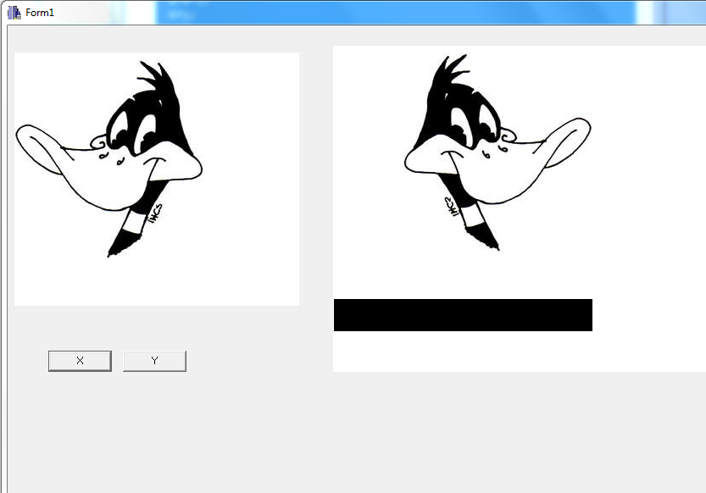

**Reflection through Y- axis**

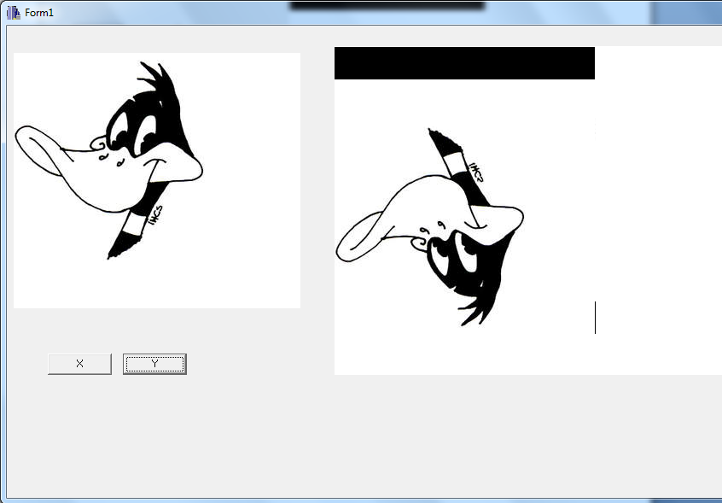

**Conclusion**

Hence we can reflect the image though x axis and y axis with the help of C++ Builder.